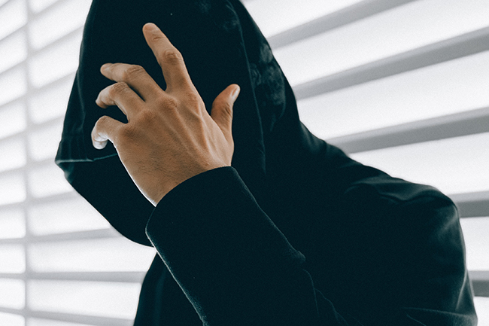

**Why are the accused's/criminal’s face is either covered by the police, or the criminals themselves, allowed to hide their faces when media cameramen take photographs of them?**

Two reasons:

1. Every accused is presumed to be innocent until proven guilty. Merely because police have arrested him, we are only assuming that he is a criminal. What if he was an innocent man? Hence it's not allowed to reveal his identity.
2. There will be an identification parade during the trial of a criminal proceeding, where people who are identical in looks will be paraded before eye witnesses and/or the victim. In such cases, if his face isn't covered, in all possibility, is easy to bring in a fake eye witness. Hence the process.

**Why are criminals allowed to hide their faces when they are on camera? Shouldn't the criminals be humiliated for what they did?**

The criminals are ordered to cover their faces. They don't cover their faces out of embarrassment or humiliation. This myth is widely propagated in India and that can be seen from the answers below.

For instance, if X is involved in raping Y, and Z has witnessed this, the courts would consider Z to be a credible witness only if X's face has not been publicly broadcasted. If everybody sees X on national television, what's the point in having a witness? How would Z's testimony be unique or valuable? Hence, the police ask the accused to cover their faces in front of the media before they present them for a fair trial in the courts.

There were many instances where the criminals were set free because their faces were publicly displayed which in turn lead to a dilution of the witness's credibility.

**Why do the police allow core criminals to cover their faces when they are presented to the media? Shouldn't they be exposed so that the public can be aware and alert of them in the future?**

What you see in the media are not **criminals**but **accused**. Only when after a trial they are convicted can they be called criminals. Another reason is that if there is an identification parade later, it is a necessary requirement so that the defence can't claim that they have been identified from media exposure.